- Part 22 (Overall dimensions: 4,67 х 3,78 mm, thickness 0,7 mm)
Material: Stainless steel (SST), Roughness, Ra=0,8

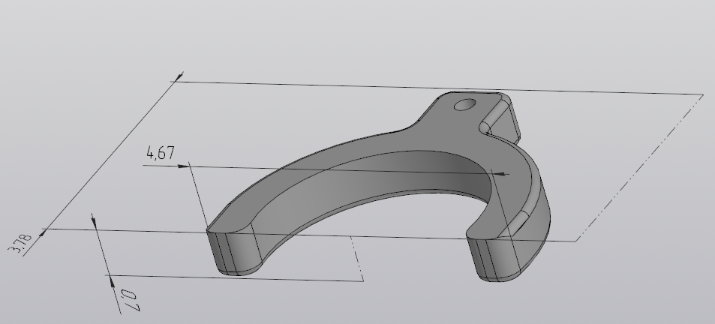

- Part 23 (Overall dimensions: Ø1 х 5 mm)
Material: Brass (BR)

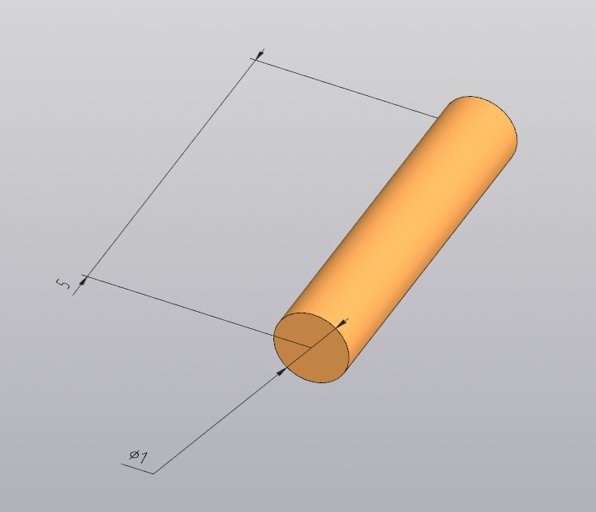

- Part 24 (Overall dimensions: Ø2 x Ø1 x 0,5 mm)
Material: Brass (BR)

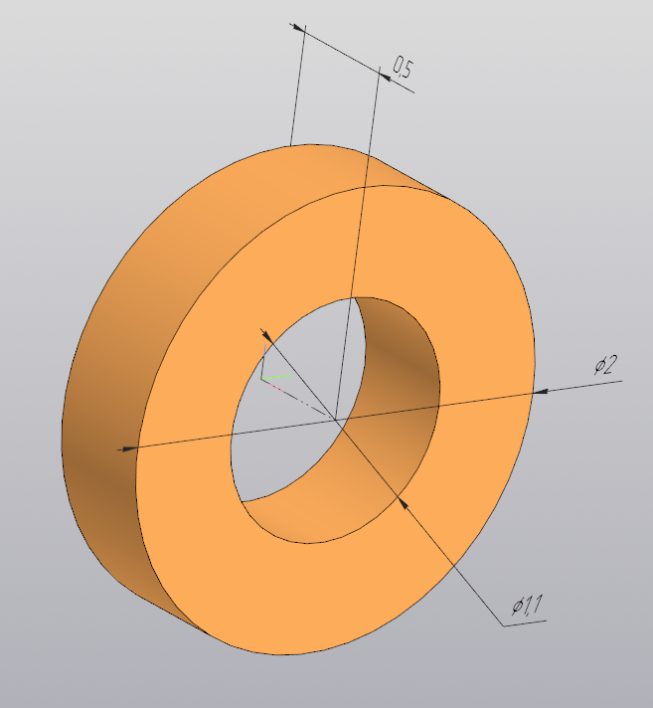

- Part 25 (Overall dimensions: Ø2 х 1,6 mm)
Material: Brass (BR)
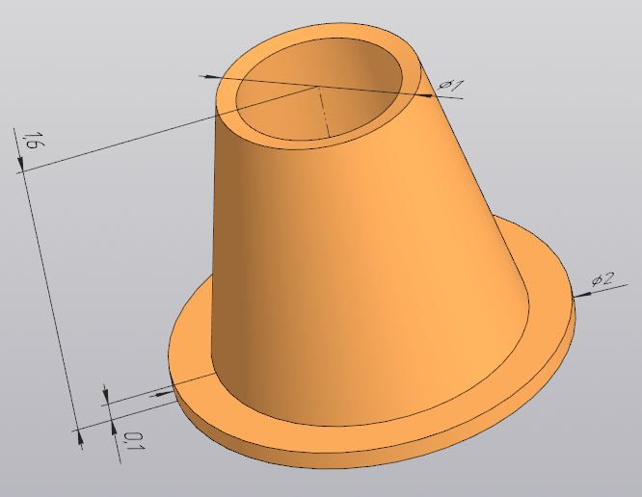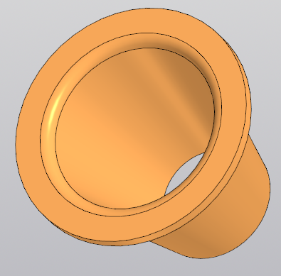

- Part 27 (Overall dimensions: Ø3 х 11 mm)
Material: spring-loaded stainless steel (сталь 50ХФА)
$D_{1}=3 mm$; $L_{0}=11 mm$; $L_{2}=9 mm$; $L_{3}=5,1 mm$; $F_{2}=2…10 N$
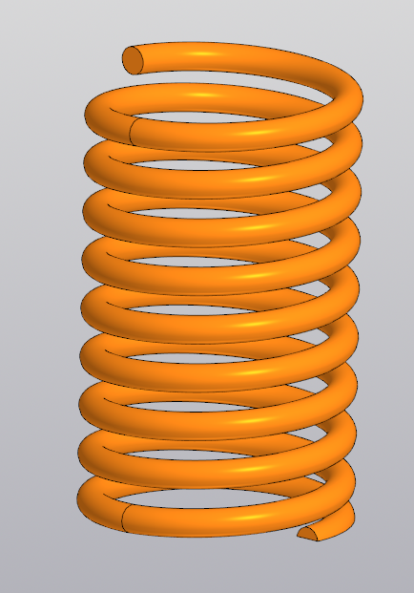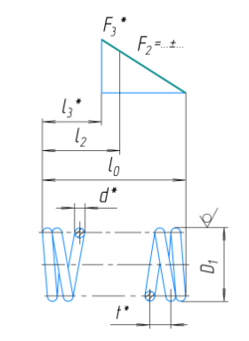

- Part 28 (Overall dimensions: 8 х 10 х 1,5 mm)
Material: spring-loaded stainless steel (сталь 50ХФА, 12Х18Н10Т)

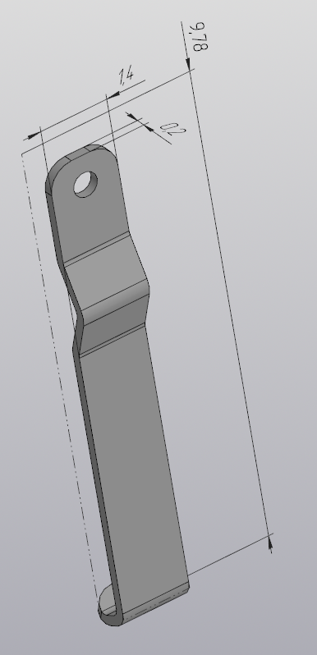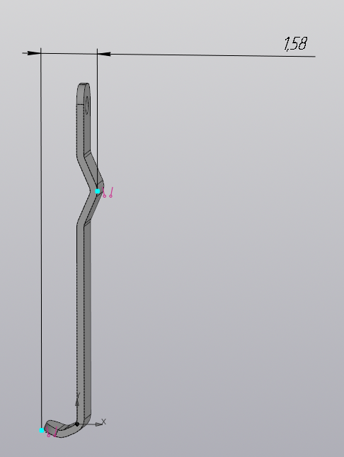

- Part 29 (Overall dimensions: 9 х 5 х 0,3 mm)
Material: Stainless steel (SST)

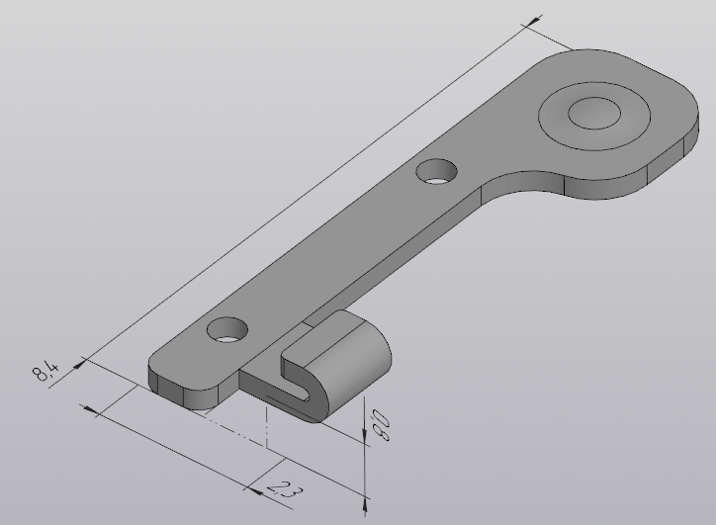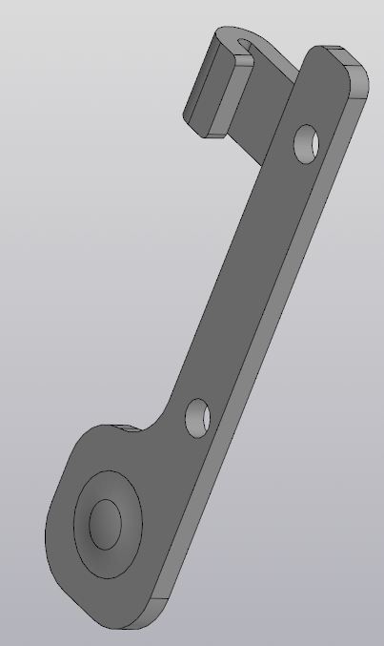

- Part 30 (Overall dimensions: 6,5 х 5 х 0,3 mm)
Material: Stainless steel (SST)

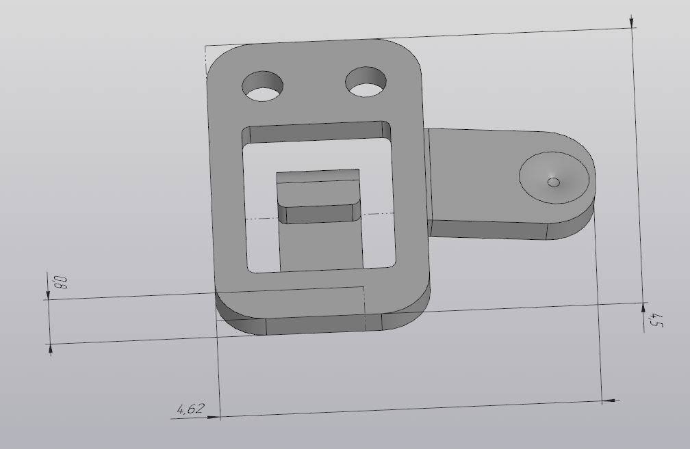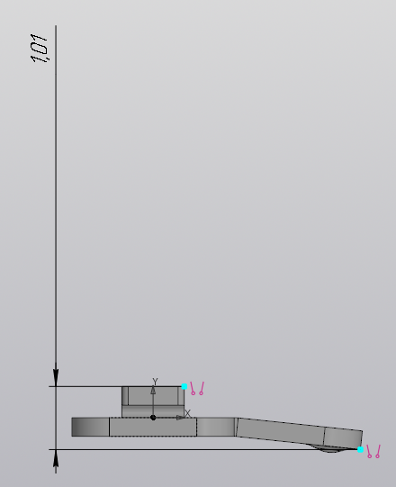

- Part 31 (Overall dimensions: 4 х 4 х 0,3 mm)
Material: Stainless steel (SST)
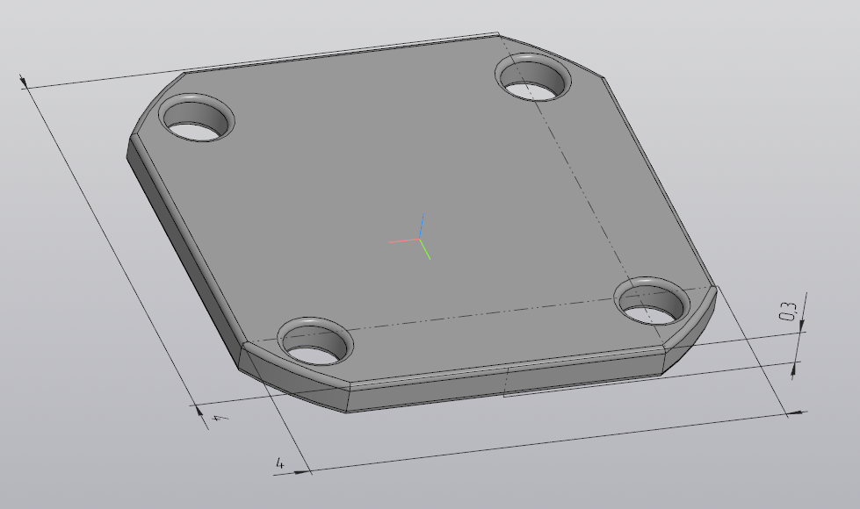

- Part 32 (Overall dimensions: Ø3 х 11 mm)
Material: spring-loaded stainless steel (сталь 50ХФА, 12Х18Н10Т)
$D_{1}=0,8 mm$; $L_{0}=14 mm$; $L_{2}=12 mm$; $L_{3}= mm$; $F_{2}=1 N$

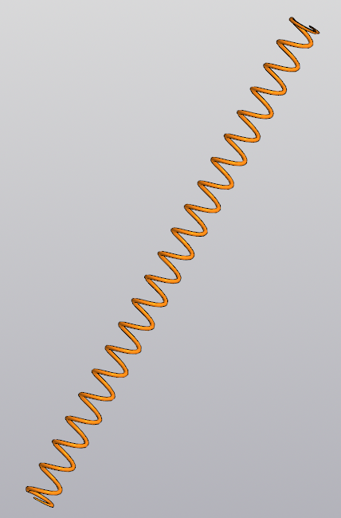

- Part 33 (Overall dimensions: 1,2 x 0,3 x 0,2 mm)
Material: Brass (BR)

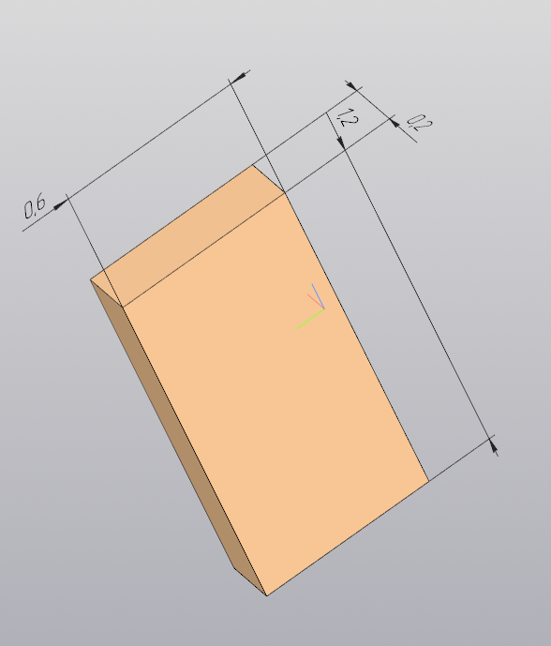

- Part 34 (Overall dimensions: Ø 0,3 x 5,2 mm)
Material: Brass (BR)

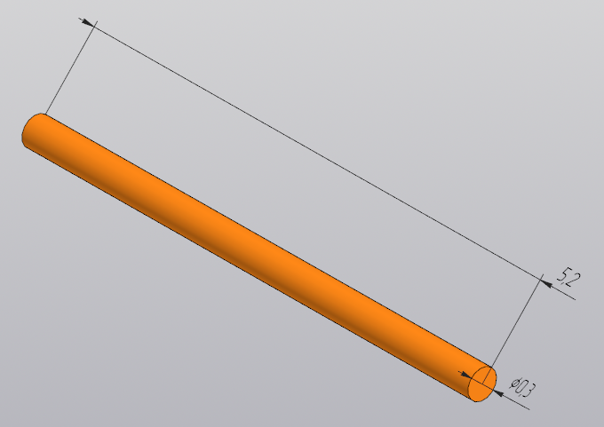

- Part 35 (Overall dimensions: Ø 0,3 x 1 mm)
Material: Brass (BR)

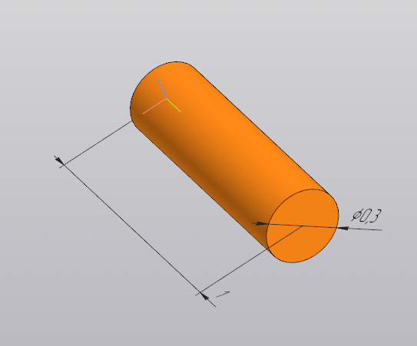

- Part 36 (Overall dimensions: Ø 1 x 2 mm)
Material: magnetic stainless steel (Сталь 40Х13 or AISI 304), Roughness, Ra=0,8

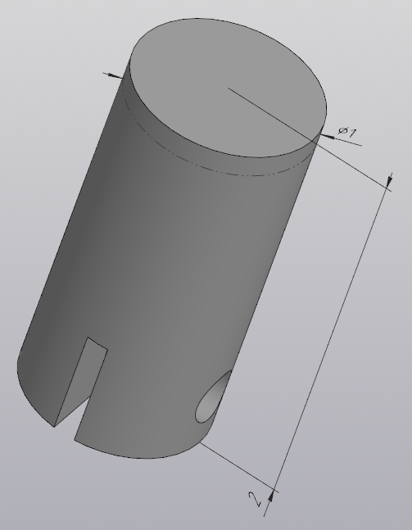
- Part 37 (Overall dimensions: 4,79 x 4,1 x 3 mm; thickness 0,1 mm)
Material: spring-loaded stainless steel (сталь 50ХФА, 12Х18Н10Т), Roughness, Ra=0,8

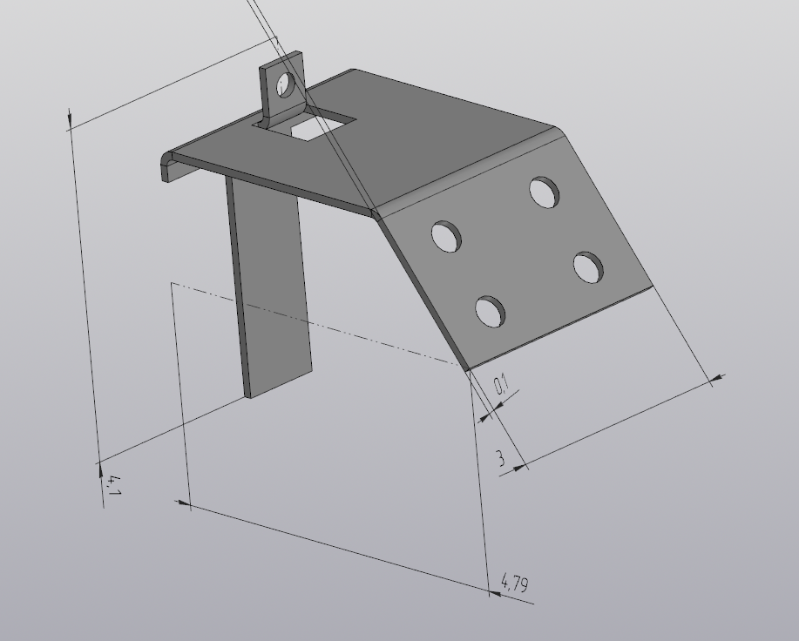

- Part 38 (Overall dimensions: 4,58 x 2,14 x 1 mm; thickness 0,1 mm)
Material: spring-loaded stainless steel (сталь 50ХФА, 12Х18Н10Т), Roughness, Ra=0,8

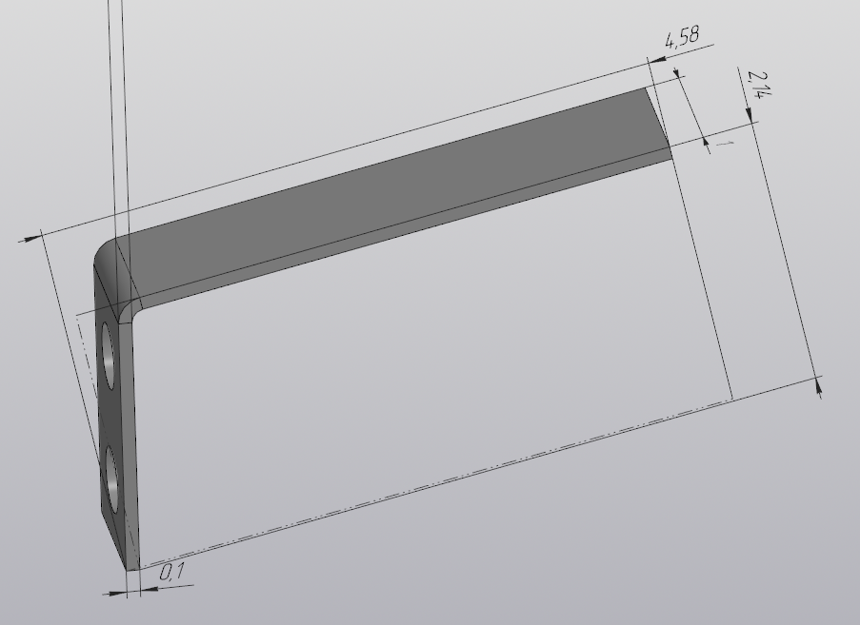

- Part 39 (Overall dimensions: Ø 2 x 16,5 mm)
Material: spring-loaded stainless steel (Сталь 40Х13 or AISI 304), Roughness, Ra=0,8…1,6

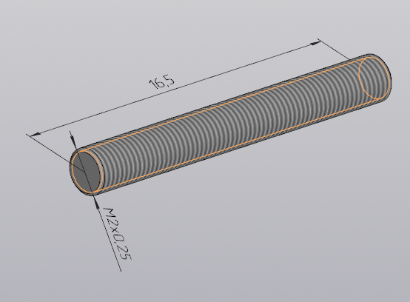

- Part 40 (Overall dimensions: Ø 2 x 16,5 mm)
Material: spring-loaded stainless steel (Сталь 40Х13 or AISI 304), Roughness, Ra=0,8…1,6

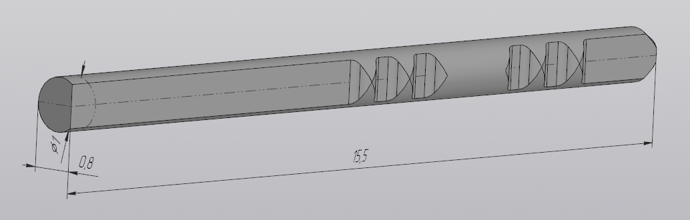
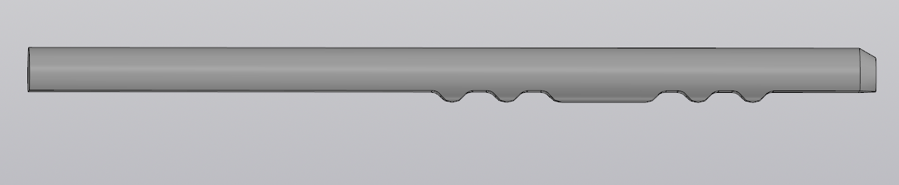

- Part 41 (Overall dimensions: Ø 0,8 х 7 mm)
Material: spring-loaded stainless steel (Сталь 50ХФА, 12Х18Н10Т)
$D_{1}=0,8 mm$; $L_{0}=7 mm$; $L_{2}=5 mm$; $L_{3}=3 mm$; $F_{2}=0,3…0,5 N$

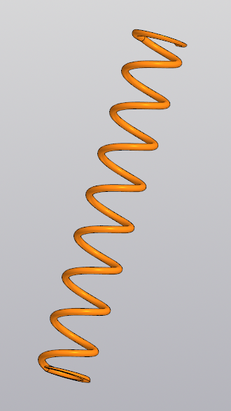

- Part 42 (Overall dimensions: Ø 0,8 х 6 mm)
Material: spring-loaded stainless steel (Сталь 50ХФА, 12Х18Н10Т)
$D_{1}=0,8 mm$; $L_{0}=6 mm$; $L_{2}=4 mm$; $L_{3}=3 mm$ $F_{2}=0,3…0,5 N$

- Part 43 (Overall dimensions: Ø 0,8 х 6 mm)
Material: spring-loaded stainless steel (Сталь 50ХФА, 12Х18Н10Т)
$D_{1}=0,8 mm$; $L_{0}=5 mm$; $L_{2}=3 mm$; $L_{3}=2 mm$; $F_{2}=0,3…0,5 N$

